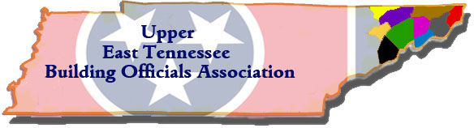

U.E.T.B.O.A
MEETING LOCATIONS 2026

January 22- Johnson City
February 26- Morristown- Weyerhouser training
March 26- Erwin
April 23- Kingsport-Site Visit to Clayton Homes Bulls Gap
May 28- Bristol
June 25- Jonesborough
July 23- Greeneville
August 27 & 28- Annual Training
September 24- Johnson City
October 22- Kingsport
November- No meeting
December- Christmas Dinner- Morristown

CHRISTMAS DINNER ROTATION

2027-Johnson City  2028-Bristol  2029-Erwin  2030-Kingsport | 2031-Jonesborough  2032-Greeneville  2033-Morristown  2034-Johnson City

